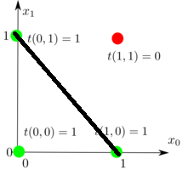

The criteria to decide which combination of $bias, w_0, w_1$ is better can vary depending on the specific problem or application. However, in general, a smaller total error would indicate a better combination. Therefore, the combination that results in the lowest total error would be considered better.

The neuron is passed into the function by reference because we want to update the values of the neuron's bias and weights based on the user's input. Passing by reference allows us to modify the original object directly, rather than creating a new copy of the object. This allows the updated values to persist outside of the function.

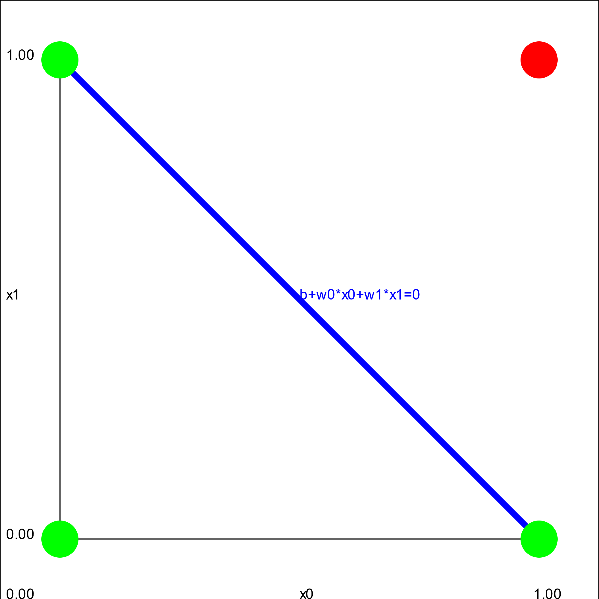

The line for the picture in exercise one is the same as the one produced in exercise 4 showing that the green dots are separated from the red dot by the line.